GO-STANDARD NURSERY & PRI-SCHOOL

END OF YEAR EXAMINATION 2023
BABY CLASS: (3 – 4 YEARS)
LEARNING AREA 2: LANGUAGE DEVELOPMENT I

My name is: …………………………………..………………………….
My School is: ……………………………..………….…………………..
I am in: ………………………………..………………………………………………..
- Match a picture to a word.

flower

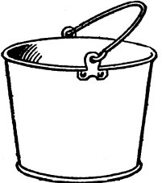

box



cup
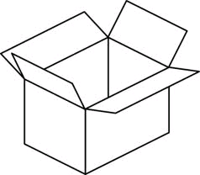

bucket


book
- Find the picture number

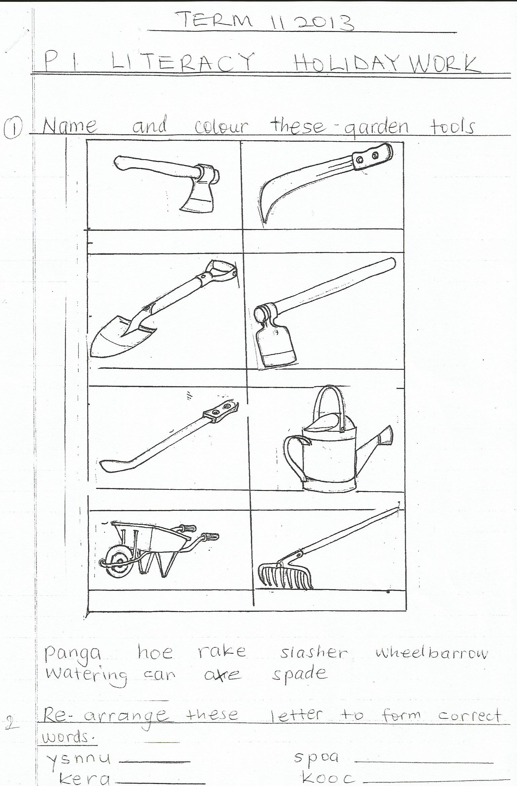
(1) 2


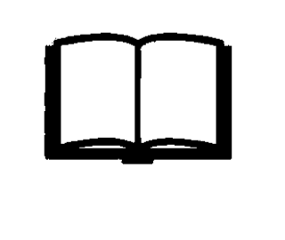
3 4

5

moon _________________________________
hoe ___________________________________
cup ___________________________________
book __________________________________
sun ____________________________________

- Match the same word.
box axe

bag ball

ball mat

axe box

mat bag

- Circle the correct word.
bga abg bag

bxo box bxo

axe exe aex

doll llod dol

cat tac cta

- Name the pictures.

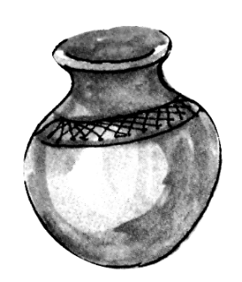

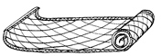

“Good Luck”

